Flag 1: Check the root ('/') directory for a file that might hold the key to the first flag on target1.ine.local.
Solution:
we must first gain access to the target’s shell.
The next step is to identify the appropriate exploit to use.

Nmap -s V target1.ine.local
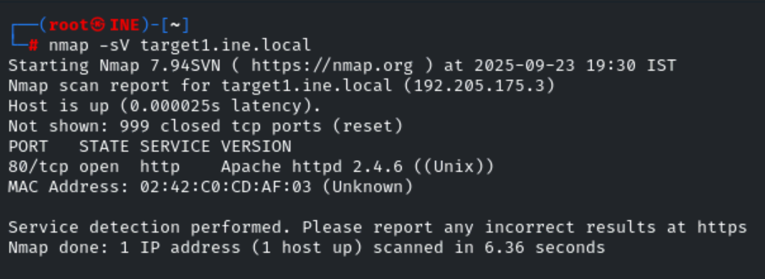
Nmap results, we identified that port 80 is open, and the server version, which is disclosed as 2.4.6 (Unix), has been found. Let's proceed by navigating to the website.

Upon navigating to the website, we observe that it redirects to /browser.cgi. The Shellshock exploit specifically targets the .cgi extension to gain access to a shell.

We’ll begin by utilizing an auxiliary module designed to check for this vulnerability. The module we’ll use is:
scanner/http/apache_mod_cgi_bash_env.
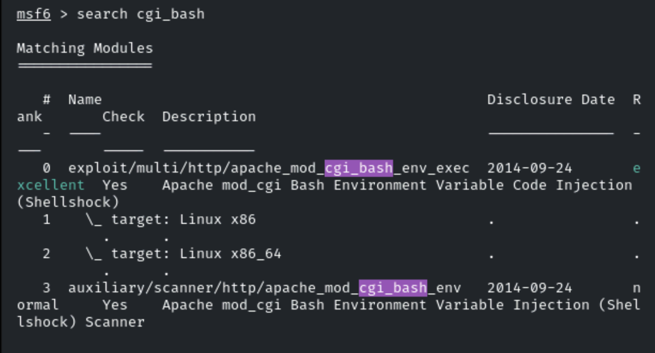
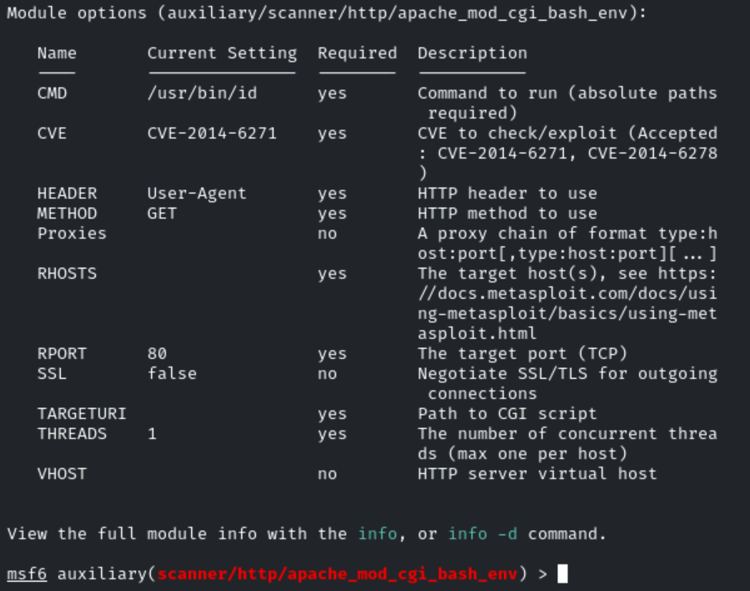
configure two parameters: the first is RHOSTS, and the second is TARGETURI.
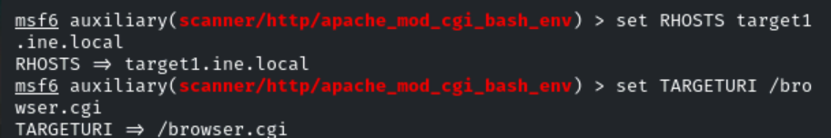
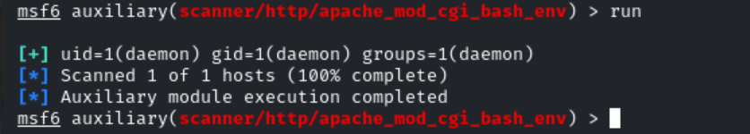

the website is indeed vulnerable to the Shellshock exploit.
let’s proceed by exploiting this vulnerability using another Metasploit
module: exploit/multi/http/apache_mod_cgi_bash_env_exec.
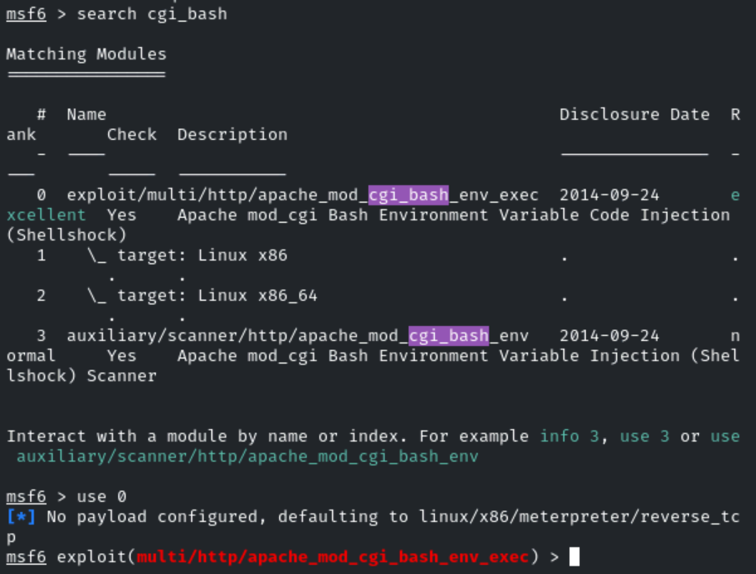
Set the options of it.
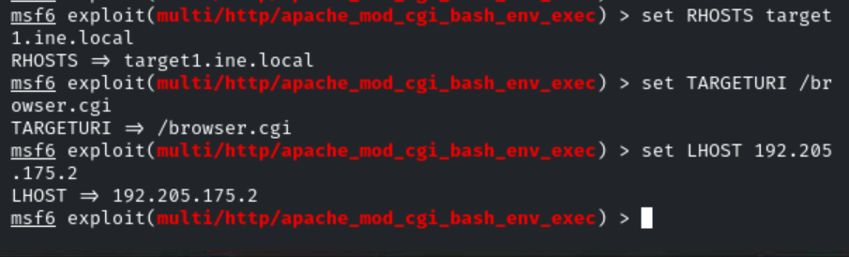
Now run/exploit it:
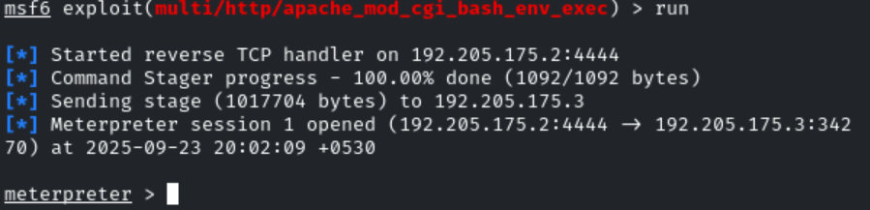
we successfully obtain our Meterpreter session.
Shell
To interact with the shell,
Make it more interactive use:
/bin/bash -i
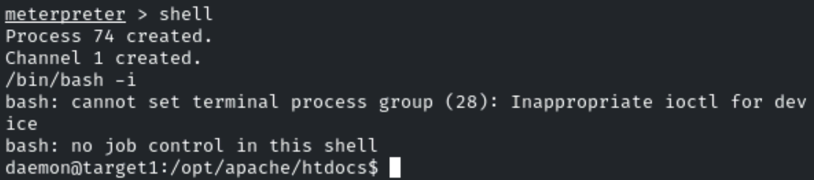
Pwd
Cd /
Ls
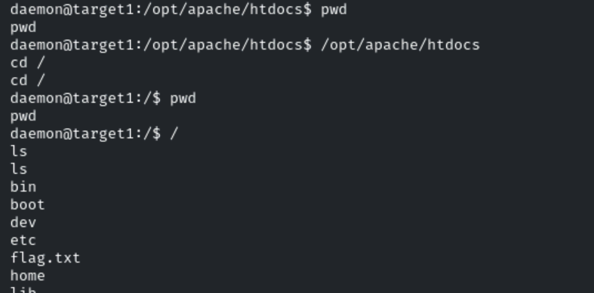
Cat flag.txt
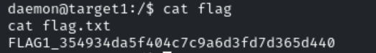
FLAG1_354934da5f404c7c9a6d3fd7d365d440

Flag 2: In the server's root directory, there might be something hidden. Explore '/opt/apache/htdocs/' carefully to find the next flag on target1.ine.local.
Solution:
Navigate to the /opt/apache/htdocs/ directory

enumerate the hidden files by running the command ls -la
cd /opt/apache/htdocs/
ls -la
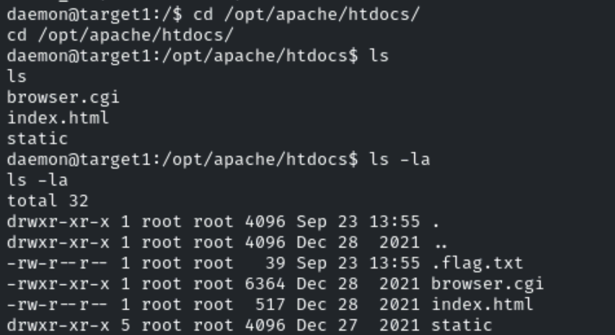

cat command to read its content.

FLAG2_817a233d2f004f5e9fcb802dfbf20607

Flag 3: Investigate the user's home directory and consider using 'libssh_auth_bypass' to uncover the flag on target2.ine.local.
Solution:
Perform Nmap scan to gather information about the target system.
Nmap -s V target1.ine.local
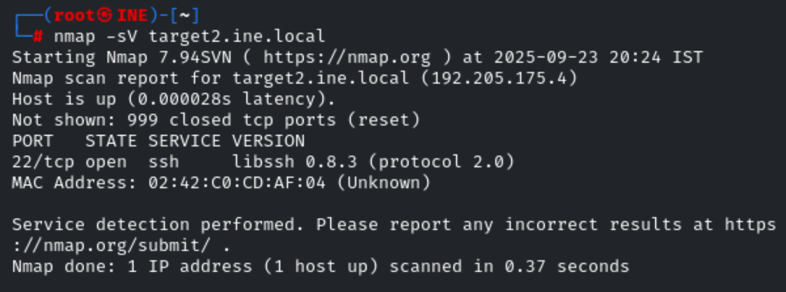
Let’s connect to Metasploit and search for any available libssh exploits.
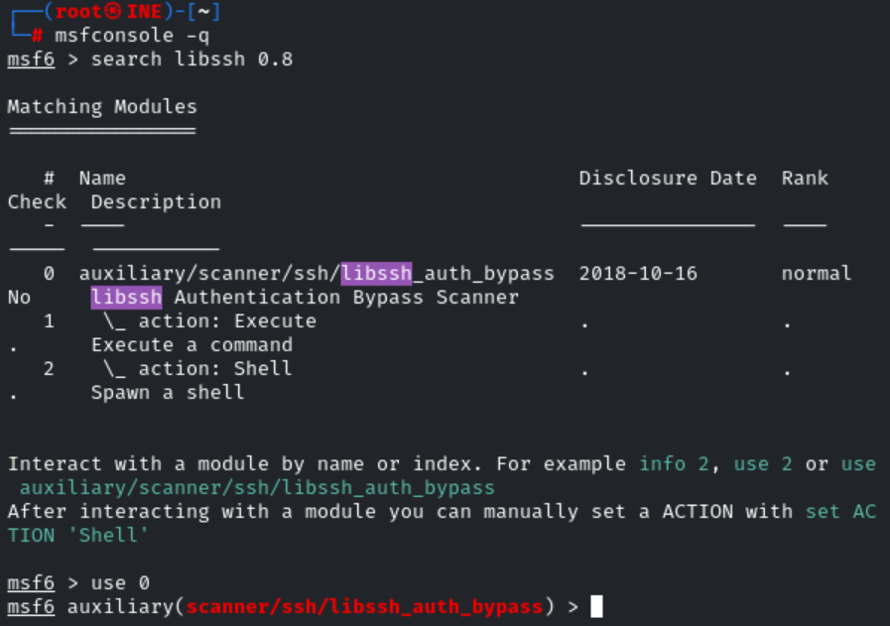
In this module, there are both auxiliary scans and the exploit itself.
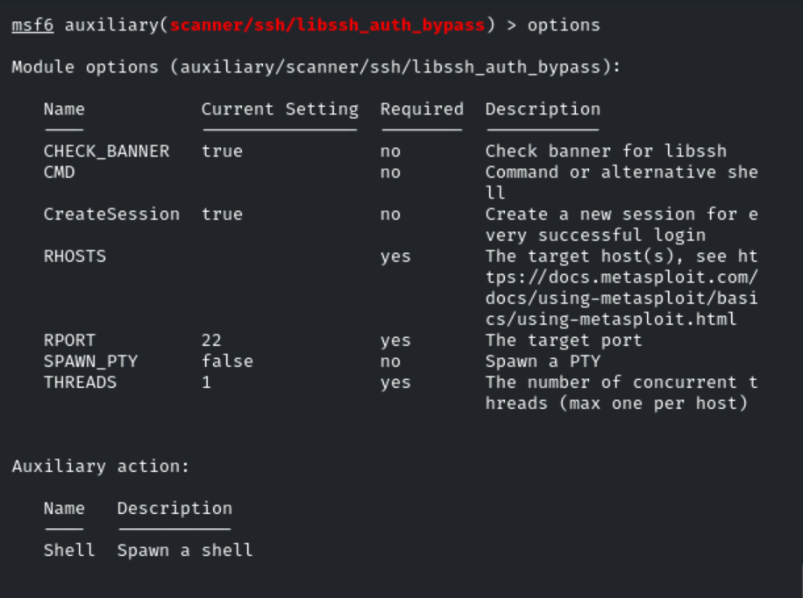

we only need to set two parameters: RHOSTS and SPAWN_PTY
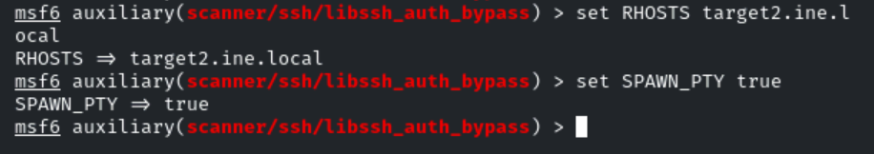
Now run it.
As the output shows, the session has been created and opened.
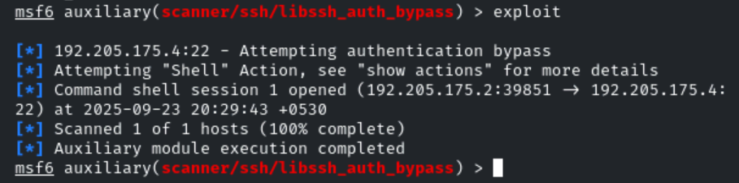
To verify, type the following command: sessions
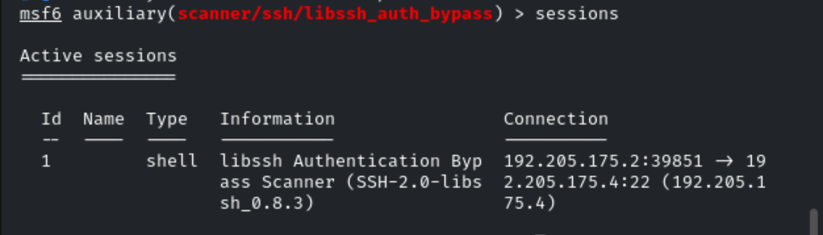
type sessions -i 1.
This will successfully grant us access to the shell.
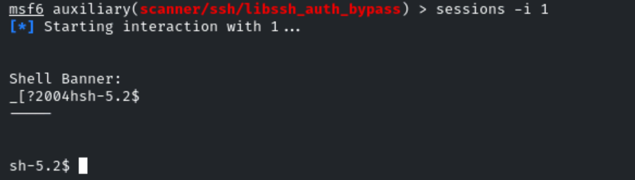
, we need to enumerate the user’s home directory.
First, navigate to the directory using the command cd /home/user, then list the contents with the ls command.
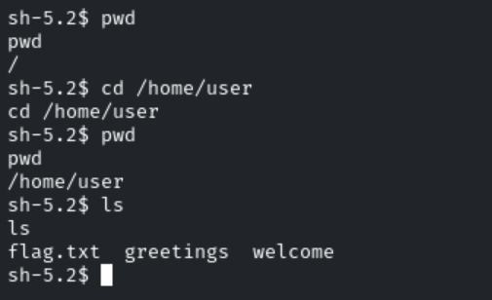
we found our third flag, which is:
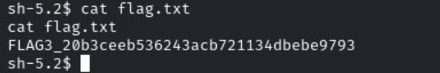
FLAG3_20b3ceeb536243acb721134dbebe9793

Flag 4: The most restricted areas often hold the most valuable secrets. Look into the '/root' directory to find the hidden flag on target2.ine.local.
Solution:
attempt to access the root directory, but when we try, it returns a ‘permission denied’ message.
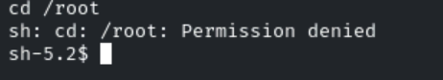
To obtain our flag, we need to elevate our privileges. As we observed while obtaining the third flag, the user directory contains two additional
files: ‘greetings’ and ‘welcome.’
By using the file command, we can confirm that both are binaries. We can utilize these binaries to escalate our privileges.
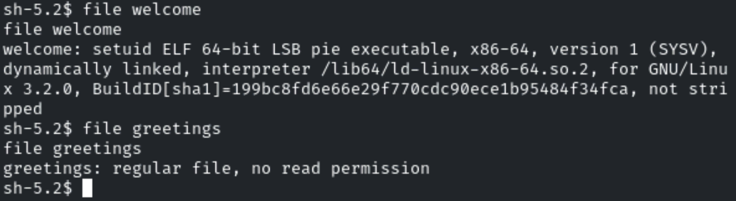
check the permissions of these two binaries. We don’t have permission to execute the ‘greetings’ binary, but we are able to execute the ‘welcome’ binary.
Now execute the welcome.
./welcome
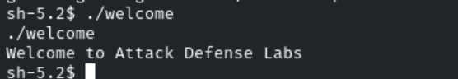
check what is used in the backend when executing the ‘welcome’ binary. To do this, we can type strings welcome.
The strings command is used to extract human-readable text embedded within the binary file. This can help us identify important information such as function names, hardcoded strings, or any other useful data that might assist in privilege escalation or reveal details about how the binary operates.
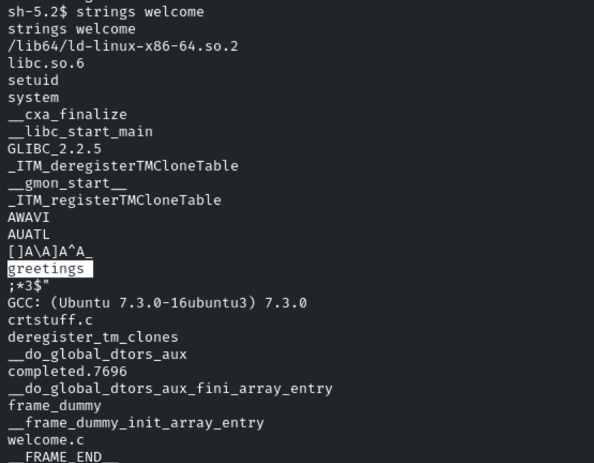
After examining the output, we discovered that the ‘welcome’ binary uses the ‘greetings’ binary, as shown in the image above.
We can delete the ‘greetings’ file from this folder and create a new ‘greetings’ file containing our custom payload.
Our payload is: cp /bin/bash greetings, which will copy the Bash shell into the 'greetings' binary, allowing us to execute it with elevated privileges.
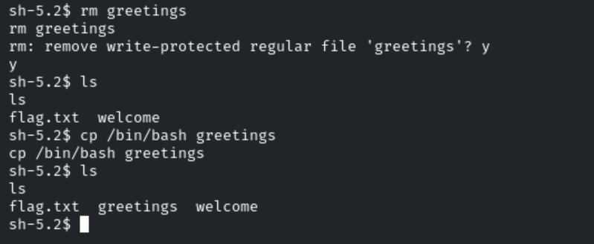
simply run the ‘welcome’ binary again by typing ./welcome
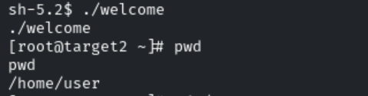

we have successfully escalated our privileges to root. Our final flag is located in the root directory, so let’s navigate to it.
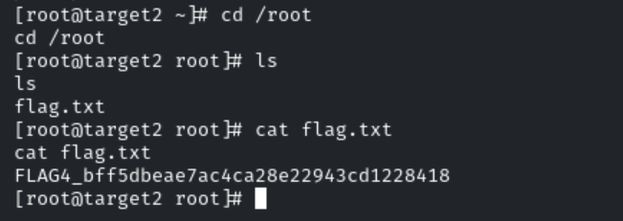

FLAG4_bff5dbeae7ac4ca28e22943cd1228418

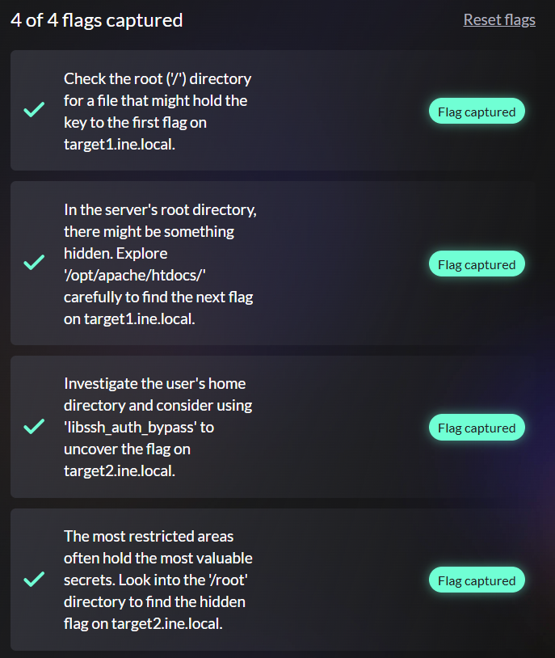
Note:
if you leave LHOST = localhost (127.0.0.1) the reverse payload will try to connect back to the target machine's loopback, not your attacker machine. That means the shell will connect to 127.0.0.1 on the victim, so you will not receive a callback unless the target itself is your machine.

SPAWN_PTY = open a proper terminal inside the shell you just got.
ELF = Linux’s standard binary format for executables and libraries.

